GROUP 1
SECURITY PROCESSOR ARCHITECTURE

1. INTRODUCTION
- Overview of security processor architecture
- Importance of secure computer systems
2. FUNDAMENTALS OF SECURITY PROCESSORS
- Definition and key concepts
- Evolution and historical background
3. SECURE EXECUTION ENVIRONMENTS
- Principles and design considerations
- Isolation techniques and trusted execution environments
4. CRYPTOGRAPHIC ACCELERATORS
- Role of hardware acceleration in cryptography
- Types of cryptographic algorithms and their implementation
5. SECURE BOOT MECHANISMS
- Boot process and its vulnerabilities
- Secure boot principles and techniques
6. TRUSTED EXECUTION ENVIRONMENTS
- Introduction to secure enclaves
- Use cases and practical applications
7. SECURITY MANAGEMENT UNITS
- Functions and responsibilities
- Access control mechanisms and secure key storage
8. SECURE MEMORY PROTECTION
- Memory encryption and isolation techniques
- Defense against memory-based attacks
9. CASE STUDIES
- Analysis of real-world security processor architectures
- Evaluation of their effectiveness and limitations
10. EMERGING TRENDS AND FUTURE DIRECTIONS
- Recent advancements in security processor architecture
- Potential areas for further research and development
11. CONCLUSION
- Summary of key findings
- Importance of security processor architecture in the modern computing landscape

INTRODUCTION
Security processor architecture is a critical aspect of computer systems that focuses on enhancing their security through dedicated hardware components. In today's digital landscape, where data breaches and cyber threats are prevalent, ensuring the security of computer systems is of utmost importance. Components of Security Processor Architecture:
1. Secure Execution Environments: These provide isolated spaces within the system where sensitive operations can be executed securely. They protect against unauthorized access and prevent malicious code from compromising the system.
2. Cryptographic Accelerators: These specialized hardware components speed up cryptographic operations, such as encryption and decryption. By offloading these tasks to dedicated accelerators, the system can efficiently handle cryptographic operations while maintaining security.
3. Secure Boot Mechanisms: Secure boot ensures that the system starts up with trusted software components. It verifies the integrity and authenticity of the bootloader and operating system, protecting against tampering and unauthorized modifications.
4. Trusted Execution Environments (TEEs): TEEs provide isolated and secure environments within the system, where critical operations can be executed with high levels of trust. They protect sensitive data and code from being accessed or modified by unauthorized entities.
5. Security Management Units (SMUs): SMUs handle security-related tasks, such as access control, secure memory management, and secure communication. They enforce security policies, monitor system activity, and prevent unauthorized actions.
6. Secure Memory Protection: This feature ensures that sensitive data stored in memory remains secure. It includes techniques like memory encryption, access control mechanisms, and memory isolation to prevent unauthorized access or tampering.
IMPORTANCE OF SECURE COMPUTER SYSTEMS:
- Secure computer systems are crucial for protecting sensitive data, preventing unauthorized access
- ensuring the integrity and availability of critical operations. In today's interconnected world
- where data breaches and cyber attacks are rampant
- organizations and individuals must prioritize the implementation of robust security measures.

By incorporating security processor architecture into computer systems, organizations can mitigate risks, safeguard sensitive information, and maintain the trust of their users. Whether it's protecting financial transactions, securing personal data, or defending against sophisticated cyber threats, secure computer systems play a vital role in maintaining a safe and reliable digital environment. In conclusion, security processor architecture is essential for enhancing the security of computer systems. By leveraging dedicated hardware components and features, organizations can bolster their defenses, protect sensitive data, and ensure the secure execution of critical operations. Implementing robust security measures is crucial in today's digital landscape, where threats to computer systems are ever-evolving.
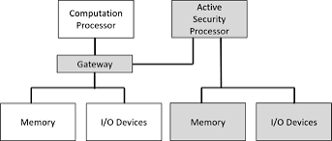

2.FUNDAMENTALS OF SECURITY PROCESSOR
- Definition and key concepts
- Evolution and historical background
fundamentals of security processors, including the definition, key concepts,and evolution. Here's the information:

Definition and Key Concepts:
A security processor, also known as a secure microcontroller or secure element, is a specialized hardware component designed to provide robust security features and protect sensitive information in various applications. It combines a microcontroller with dedicated security features to ensure the confidentiality, integrity, and availability of data.

Key concepts in security processors include:

1. Secure Boot: The process of verifying the integrity and authenticity of the firmware or software running on the security processor before allowing it to execute. This helps prevent unauthorized or malicious code from running.

2. Cryptographic Operations: Security processors often include hardware accelerators for cryptographic algorithms, such as encryption, decryption, digital signatures, and key generation. These operations are performed securely and efficiently, protecting sensitive data.

3. Secure Storage: Security processors have built-in secure storage areas, such as secure flash memory or tamper-resistant hardware modules, to store sensitive data, cryptographic keys, and certificates. These storage areas are designed to resist physical attacks and prevent unauthorized access.

4. Secure Communication: Security processors provide secure communication channels, such as secure protocols and cryptographic algorithms, to protect data transmission between the processor and other devices. This ensures the confidentiality and integrity of the communication.

Evolution and Historical Background:
The need for security processors arose due to the increasing threats to data security in various applications. Over time, security processors have evolved to meet the growing demands of secure systems. Here's a brief historical background:

1. Early Security Modules: In the 1980s, security modules started emerging to protect sensitive data in banking and financial systems. These modules provided hardware-based encryption and secure key storage.

2. Smart Cards: In the 1990s, smart cards gained popularity as portable security processors. They were used for secure authentication, payment systems, and secure access control. Smart cards integrated microcontrollers, secure storage, and cryptographic functions.

3. Trusted Platform Modules (TPM): In the early 2000s, TPMs were introduced as dedicated security processors for personal computers. TPMs provided secure storage, cryptographic functions, and platform integrity measurements.

4. Secure Elements: With the rise of mobile devices and Internet of Things (IoT), secure elements became essential for securing sensitive data in these devices. Secure elements are embedded security processors used in smartphones, wearables, and IoT devices.

5. Integrated Security Processors: Modern security processors are integrated into various

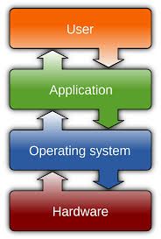

3. SECURE EXECUTION ENVIRONMENTS
- Principles and design considerations
- Isolation techniques and trusted execution environments

Principles and Design Considerations:
Secure execution environments (SEEs) are designed to provide a trusted and isolated environment for executing sensitive code and protecting critical data. The principles and design considerations of SEEs include:

1. Isolation: SEEs aim to isolate the execution of sensitive code and data from the rest of the system. This isolation prevents unauthorized access and tampering, ensuring the confidentiality and integrity of the execution environment.

2. Trusted Computing Base (TCB): The TCB refers to the set of hardware and software components that are trusted to correctly enforce security policies in an SEE. Minimizing the size of the TCB reduces the attack surface and enhances the security of the execution environment.

3. Secure Boot: SEEs often employ secure boot mechanisms to ensure the integrity and authenticity of the software components loaded during the boot process. This prevents the execution of unauthorized or tampered code.

4. Memory Protection: SEEs utilize memory protection mechanisms to isolate the memory regions used by the secure code and data from the rest of the system. This prevents unauthorized access and tampering of sensitive information.

5. Cryptographic Operations: SEEs often include dedicated hardware for cryptographic operations, such as encryption, decryption, and digital signatures. These hardware accelerators ensure secure and efficient execution of cryptographic algorithms.

Isolation Techniques and Trusted Execution Environments:
To achieve isolation and create trusted execution environments, SEEs employ various techniques and technologies. Here are some commonly used isolation techniques and trusted execution environments:

1. Hardware Isolation: SEEs can leverage hardware features, such as secure enclaves or secure zones, provided by modern processors. These hardware-based isolation mechanisms create a trusted execution environment within the processor itself, protecting the code and data from external threats.

2. Virtualization: Virtualization technologies, such as hypervisors, can be used to create isolated virtual machines (VMs) or containers for executing sensitive code. Each VM or container operates independently, providing a secure execution environment.

3. Trusted Execution Environments (TEEs): TEEs are secure enclaves within a device's main processor. TEEs provide a highly isolated and trusted environment for executing sensitive code and protecting critical data. Examples of TEEs include Intel SGX and ARM TrustZone.

4. Secure Elements: Secure elements, such as embedded secure chips or smart cards, provide a dedicated hardware-based execution environment
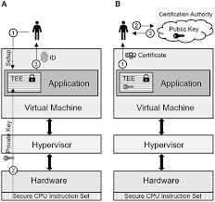

4. CRYPTOGRAPHIC ACCELERATORS
- Role of hardware acceleration in cryptography
- Types of cryptographic algorithms and their implementation

Role of Hardware Acceleration in Cryptography:
Hardware acceleration plays a crucial role in cryptography by offloading computationally intensive cryptographic operations to dedicated hardware components. This acceleration improves the performance and efficiency of cryptographic algorithms, making them faster and more secure. Here are some key roles of hardware acceleration in cryptography:

1. Speed and Efficiency: Cryptographic algorithms involve complex mathematical operations, such as encryption, decryption, hashing, and digital signatures. Hardware accelerators are designed to perform these operations efficiently, significantly reducing the time required for cryptographic computations.

2. Secure Key Generation: Cryptographic accelerators often include dedicated hardware for secure key generation. These hardware components generate random and unpredictable cryptographic keys, which are essential for ensuring the security of cryptographic systems.

3. Secure Key Storage: Hardware accelerators provide secure storage for cryptographic keys, protecting them from unauthorized access and tampering. This prevents the exposure of sensitive keys, which are critical for maintaining the confidentiality and integrity of cryptographic operations.

4. Protection Against Side-Channel Attacks: Side-channel attacks exploit information leaked during cryptographic computations, such as power consumption or timing variations. Hardware accelerators are designed to mitigate these attacks by implementing countermeasures, such as constant-time algorithms or power analysis resistance.

Types of Cryptographic Algorithms and Their Implementation:
Cryptographic algorithms are classified into different categories based on their specific applications and properties. Here are some common types of cryptographic algorithms and their implementation:

1. Symmetric Key Algorithms: Symmetric key algorithms use the same key for both encryption and decryption. Examples include the Advanced Encryption Standard (AES), Data Encryption Standard (DES), and Triple DES (3DES). Hardware accelerators implement these algorithms using specialized circuits optimized for fast and secure symmetric key operations.

2. Asymmetric Key Algorithms: Asymmetric key algorithms, also known as public-key algorithms, use a pair of mathematically related keys: a public key for encryption and a private key for decryption. Examples include RSA, Diffie-Hellman, and Elliptic Curve Cryptography (ECC). Hardware accelerators implement these algorithms using dedicated circuits that perform modular arithmetic operations efficiently.

3. Hash Functions: Hash functions generate fixed-size output (hash) from variable-size input data. They are used for data integrity verification and password storage. Examples include the Secure Hash Algorithm (SHA) family (e.g., SHA-256, SHA-3) and Message Digest Algorithm
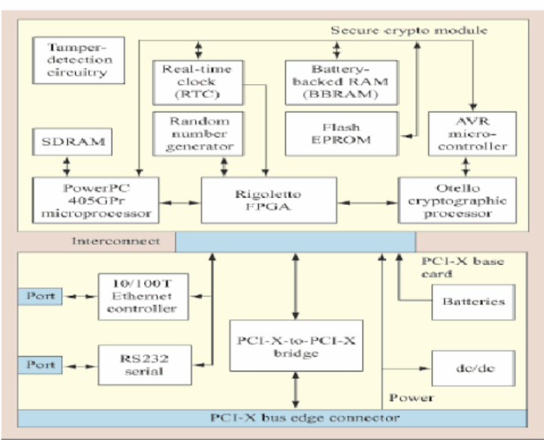

5. SECURE BOOT MECHANISMS
- Boot process and its vulnerabilities
- Secure boot principles and techniques

Boot Process and its Vulnerabilities:
The boot process is the sequence of steps that a computer system goes through when starting up. It involves loading and initializing the operating system and other software components. However, the boot process can be vulnerable to attacks, such as malware injection or unauthorized modifications, which can compromise the integrity and security of the system. Here are some common vulnerabilities in the boot process:

1. Bootkits and Rootkits: These are types of malware that infect the boot process and gain control over the system. They can modify or replace components of the boot process, allowing attackers to maintain persistence and control over the system.

2. Unauthorized Firmware or Bootloader Modifications: Attackers may tamper with the firmware or bootloader, which are responsible for initializing the hardware and loading the operating system. Unauthorized modifications can lead to the execution of malicious code or the bypassing of security controls.

3. Supply Chain Attacks: Malicious actors may compromise the integrity of the boot process during the manufacturing or distribution stages. They can insert backdoors or modify firmware or software components, which can be exploited later to gain unauthorized access or control over the system.

Secure Boot Principles and Techniques:
Secure boot is a mechanism that ensures the integrity and authenticity of the boot process, protecting against unauthorized modifications and malware injections. It relies on a combination of hardware and software techniques to establish a chain of trust from the initial boot stages to the loading of the operating system. Here are some principles and techniques used in secure boot:

1. Cryptographic Verification: Secure boot uses cryptographic techniques to verify the integrity and authenticity of the boot components. This involves using digital signatures to ensure that only trusted and unmodified code is executed during the boot process.

2. Trusted Boot Process: Secure boot establishes a trusted boot process by verifying the integrity of each component loaded during the boot sequence. This includes verifying the firmware, bootloader, and operating system components against trusted measurements or signatures.

3. Secure Boot Keys: Secure boot relies on a set of trusted keys to verify the authenticity of the boot components. These keys are securely stored in hardware or firmware and are used to validate the digital signatures of the boot components.

- Secure Boot Environments: Secure boot provides a secure environment, such as a trusted platform module (TPM) or secure boot firmware, where the boot process can be securely measured, verified, and enforced. These environments
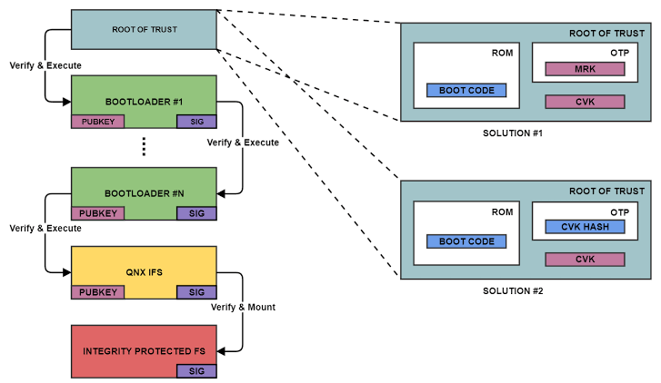

6. TRUSTED EXECUTION ENVIRONMENTS
- Introduction to secure enclaves
- Use cases and practical applications

Introduction to Secure Enclaves:
Secure enclaves, also known as Trusted Execution Environments (TEEs), are isolated and protected areas within a computer system's memory that provide a secure and trusted environment for executing sensitive code and protecting sensitive data. TEEs are designed to be resistant to attacks, even if the underlying operating system or other software layers are compromised. They offer a higher level of security and confidentiality compared to the regular execution environment.

Use Cases and Practical Applications:
Secure enclaves have various use cases and practical applications across different industries. Here are some examples:

1. Secure Cryptographic Operations: TEEs are commonly used for performing secure cryptographic operations such as key generation, encryption, and decryption. By executing these operations within a secure enclave, the sensitive cryptographic keys and data are protected from unauthorized access or tampering.

2. Secure Mobile Applications: TEEs are utilized in mobile devices to provide a secure environment for storing and processing sensitive information, such as biometric data (fingerprint, facial recognition) or payment credentials. TEEs ensure that this data remains protected even if the device's operating system or other applications are compromised.

3. Digital Rights Management (DRM): TEEs play a crucial role in DRM systems by securely storing and executing the decryption keys and algorithms required to protect copyrighted content. This prevents unauthorized access or copying of digital media, ensuring content providers' rights are protected.

4. Secure Remote Attestation: TEEs enable secure remote attestation, which allows a remote party to verify the integrity and security of a device's software and hardware configuration. This is useful in scenarios such as secure device provisioning, secure remote access, or establishing trust between different entities in a distributed system.

5. Confidential Computing: TEEs are a fundamental component of confidential computing, where sensitive workloads and data are processed in a secure and trusted environment. This ensures that the data remains confidential and protected, even from the cloud service provider or other entities involved in the processing.

Overall, Trusted Execution Environments provide a secure and isolated environment for executing sensitive code and protecting sensitive data, enabling various applications that require a high level of security and confidentiality.
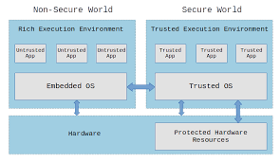

7. SECURITY MANAGEMENT UNITS
- Functions and responsibilities
- Access control mechanisms and secure key storage

Functions and Responsibilities of Security Management Units:
Security Management Units (SMUs) are dedicated hardware components or software modules that are responsible for managing and enforcing security policies within a system. They perform various functions to ensure the security and integrity of the system. Here are some key functions and responsibilities of SMUs:

1. Access Control: SMUs are responsible for enforcing access control policies by determining and managing the permissions and privileges of different entities within the system. They authenticate and authorize users or processes based on predefined rules and policies, ensuring that only authorized entities can access specific resources or perform certain actions.

2. Secure Boot: SMUs play a crucial role in ensuring the integrity of the system's boot process. They verify the authenticity and integrity of the system firmware, bootloader, and operating system during the boot-up process. This helps prevent unauthorized modifications or tampering with the system's software stack.

3. Secure Key Storage: SMUs provide a secure environment for storing cryptographic keys and other sensitive information. They use hardware-based security mechanisms to protect the keys from unauthorized access or extraction. This ensures the confidentiality and integrity of cryptographic operations and prevents key compromise.

4. Secure Communication: SMUs facilitate secure communication between different entities within the system. They can enforce secure communication protocols, encrypt and decrypt data, and verify the authenticity of communication endpoints. This helps protect sensitive data from eavesdropping, tampering, or unauthorized access.

5. Intrusion Detection and Prevention: SMUs can monitor the system for any suspicious or malicious activities. They can detect and prevent attacks such as buffer overflows, code injection, or unauthorized access attempts. SMUs can also generate alerts or take proactive measures to mitigate potential security threats.

Access Control Mechanisms and Secure Key Storage:
SMUs employ various access control mechanisms and secure key storage techniques to ensure the confidentiality and integrity of the system. Some commonly used mechanisms include:

1. Role-Based Access Control (RBAC): RBAC is a widely used access control model where access permissions are assigned based on the roles or responsibilities of users or processes. SMUs enforce RBAC policies by granting or denying access based on predefined rules.

2. Secure Elements: SMUs often incorporate secure elements, such as hardware security modules (HSMs) or trusted platform modules (TPMs), for secure key storage. These secure elements provide tamper-resistant storage and cryptographic operations,
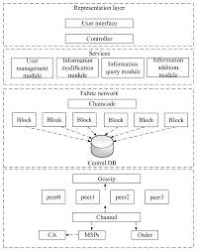

8. SECURE MEMORY PROTECTION
- Memory encryption and isolation techniques
- Defense against memory-based attacks

Secure Memory Protection involves implementing measures to safeguard the confidentiality and integrity of data stored in computer memory. It aims to prevent unauthorized access, tampering, or leakage of sensitive information. Two key aspects of Secure Memory Protection are memory encryption and isolation techniques, along with defense against memory-based attacks.

1. Memory Encryption: Memory encryption is a technique that involves encrypting the data stored in memory to protect it from unauthorized access. This ensures that even if an attacker gains access to the memory, the data remains encrypted and unreadable without the appropriate decryption key. Memory encryption can be implemented at different levels, such as full memory encryption or selective encryption of specific memory regions.

2. Memory Isolation: Memory isolation is the practice of separating different processes or applications running on a system to prevent unauthorized access or interference between them. This is achieved by allocating separate memory spaces for each process, ensuring that they cannot access or modify the memory of other processes. Memory isolation helps mitigate the risk of data leakage or unauthorized access between different applications or processes.

3. Defense Against Memory-Based Attacks: Secure Memory Protection also involves implementing measures to defend against memory-based attacks. These attacks exploit vulnerabilities in the memory management system to gain unauthorized access to sensitive data or execute malicious code. Some common memory-based attacks include buffer overflows, heap overflows, and code injection attacks. Defense mechanisms such as Address Space Layout Randomization (ASLR), Data Execution Prevention (DEP), and Control Flow Integrity (CFI) can be employed to detect and prevent these attacks.

By implementing memory encryption and isolation techniques, along with defense mechanisms against memory-based attacks, Secure Memory Protection helps ensure the confidentiality, integrity, and availability of data stored in computer memory. It is an essential component of overall system security, particularly in environments where sensitive information is processed or stored.

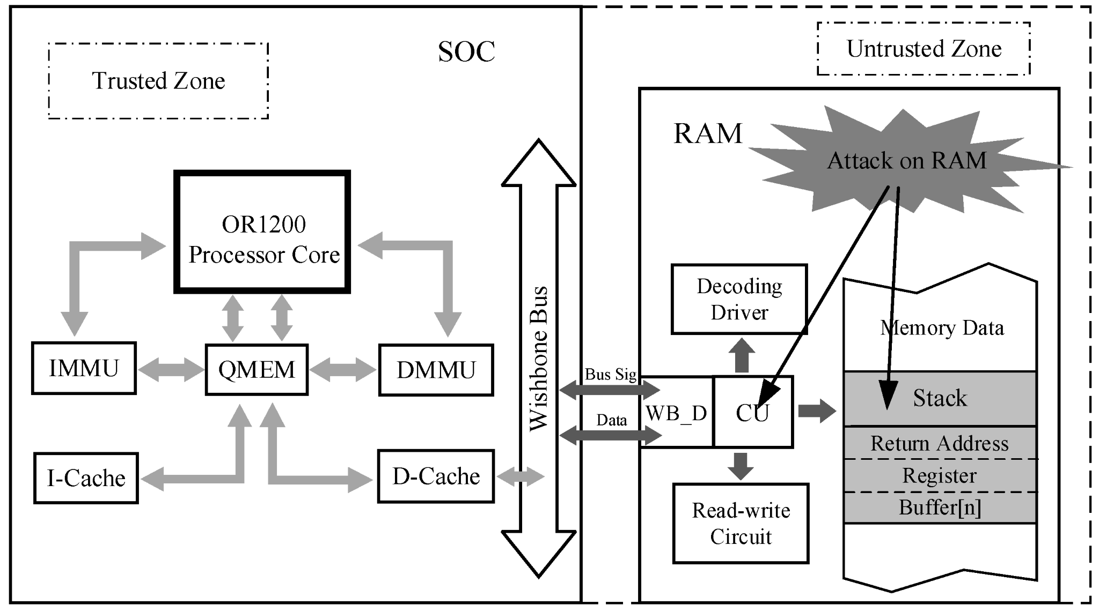

9. CASE STUDIES
- Analysis of real-world security processor architectures
- Evaluation of their effectiveness and limitations

Case studies play a crucial role in understanding how security processor architectures are designed, implemented, and perform in real-world scenarios. These studies provide valuable insights into the strengths and weaknesses of different security processor architectures, enabling researchers and developers to make informed decisions when designing secure systems.

In these case studies, researchers typically select specific security processor architectures and thoroughly analyze their design principles, security features, and implementation details. They often evaluate the effectiveness of these architectures in protecting against various types of attacks, such as side-channel attacks, fault injection attacks, and software-based attacks.

The analysis involves examining the security mechanisms implemented within the processor, such as secure boot, secure memory protection, secure key storage, and secure communication interfaces. Researchers also assess the architecture's resistance to physical attacks, such as tampering, reverse engineering, and invasive probing.

By conducting these case studies, researchers gain a deeper understanding of the strengths and weaknesses of different security processor architectures. They can identify potential vulnerabilities and propose improvements to enhance the security of these architectures. Additionally, these studies contribute to the overall knowledge base in the field of secure systems and help drive advancements in security processor design.

It's worth noting that case studies may focus on specific architectures used in various domains, such as embedded systems, mobile devices, automotive systems, or cloud infrastructure. Each domain has its unique security requirements and challenges, which are taken into account during the analysis.

Overall, case studies analyzing real-world security processor architectures provide valuable insights into their effectiveness and limitations. They contribute to the continuous improvement of secure systems, helping to create a safer digital environment for users and organizations alike.

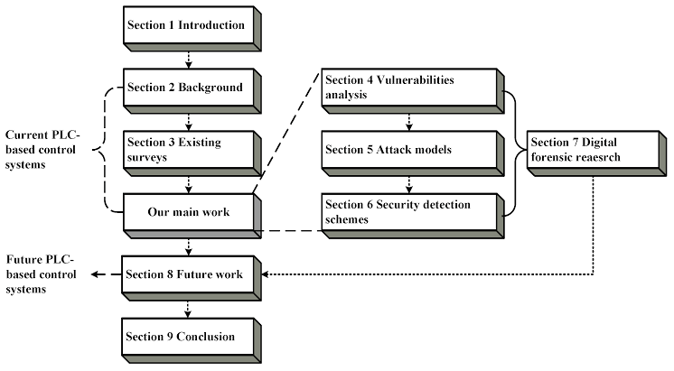

10. EMERGING TRENDS AND FUTURE DIRECTIONS
- Recent advancements in security processor architecture
- Potential areas for further research and development

In recent years, there have been significant advancements in security processor architecture that aim to address the ever-evolving landscape of cybersecurity threats. One notable trend is the integration of hardware-based security features directly into processors, providing enhanced protection against attacks. These features may include secure enclaves, hardware-based encryption, and secure memory management.

Another emerging trend is the adoption of trusted execution environments (TEEs) within security processors. TEEs create isolated and secure execution environments, allowing sensitive computations and data to be protected from potential threats. This technology has gained traction in various domains, including mobile devices, cloud computing, and Internet of Things (IoT) devices.

Moreover, there is a growing focus on mitigating side-channel attacks, which exploit information leaked through unintended channels, such as power consumption or electromagnetic radiation. Researchers are exploring innovative techniques to enhance the resistance of security processors against these attacks, including improved power management, noise reduction, and advanced cryptographic algorithms.

Looking ahead, there are several potential areas for further research and development in security processor architecture. One area of interest is the development of more efficient and scalable hardware-based security mechanisms. This involves exploring novel approaches to secure key management, secure bootstrapping, and secure communication protocols.

Additionally, as the complexity of security threats continues to increase, there is a need for more comprehensive security assurance methodologies. Researchers are working on developing rigorous testing and validation techniques to ensure the effectiveness and reliability of security processor architectures. This includes techniques such as formal verification, hardware emulation, and advanced simulation environments.

Furthermore, the integration of artificial intelligence and machine learning techniques into security processor architectures shows promise in improving threat detection and mitigation capabilities. These technologies can enable processors to adaptively respond to emerging threats and identify anomalous behaviors in real-time.

In conclusion, the field of security processor architecture is continuously evolving, driven by recent advancements and the need for robust protection against cybersecurity threats. The future holds exciting possibilities for further research and development, including advancements in hardware-based security features, mitigation of side-channel attacks, comprehensive security assurance methodologies, and the integration of artificial intelligence. These advancements will shape the future of secure systems and contribute to a safer digital environment.

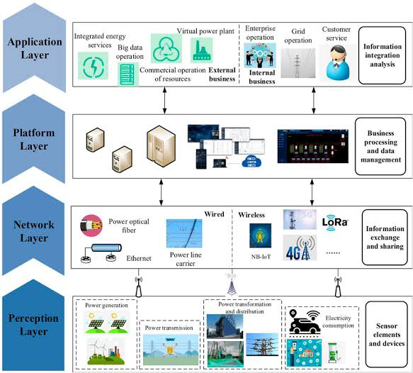

11. CONCLUSION
- Summary of key findings
- Importance of security processor architecture in the modern computing landscape

In conclusion, we have explored the exciting world of security processor architecture and its significance in today's computing landscape. We discussed recent advancements in security processor architecture, such as the integration of hardware-based security features and the adoption of trusted execution environments (TEEs). These advancements aim to provide enhanced protection against cybersecurity threats and ensure the security of sensitive data and computations.

We also touched upon the emerging trends and future directions in security processor architecture, including the focus on mitigating side-channel attacks and the need for more efficient and scalable hardware-based security mechanisms. Additionally, we highlighted the importance of comprehensive security assurance methodologies to ensure the effectiveness and reliability of security processor architectures.

It is crucial to recognize the importance of security processor architecture in the modern computing landscape. As technology continues to advance, so do the sophistication and prevalence of cybersecurity threats. Security processor architectures play a vital role in safeguarding sensitive information, protecting against unauthorized access, and ensuring the integrity and confidentiality of data.

In an increasingly interconnected world, where digital systems are integral to our daily lives, security processor architecture provides the foundation for building secure and trustworthy computing systems. It enables organizations and individuals to mitigate the risks associated with cyberattacks, safeguard their assets, and maintain the privacy and trust of their users.

By investing in research and development in security processor architecture, we can continue to stay ahead of evolving threats and ensure the resilience of our digital infrastructure. It is a collaborative effort involving researchers, engineers, and industry professionals to design and implement robust security measures that protect against both known and emerging threats.

In conclusion, security processor architecture is a critical component of modern computing, enabling us to navigate the digital landscape with confidence and trust. As technology continues to evolve, so must our security measures, and security processor architecture will continue to play a crucial role in securing our digital future.

